Honors Geometry Name _______________________________

Semester 2 Final Exam Review Hour ______

1. Solve for x and y in the triangle below.

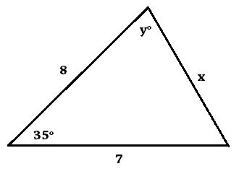

2. Assuming the polygons below are similar, solve for x and y.

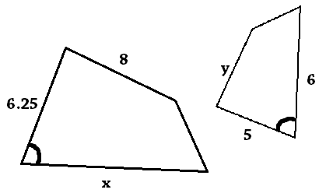

3. Solve for a, b, c, x, and y in the picture below.

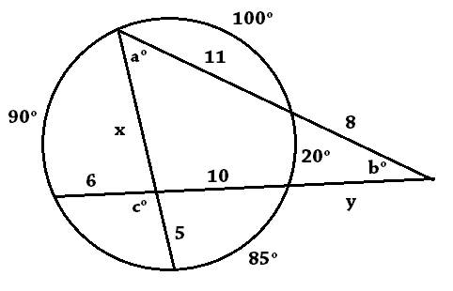

4. How far away (in miles) could you see fireworks that are shot 175 feet high? (Assume the diameter of the earth is 7920 miles.)

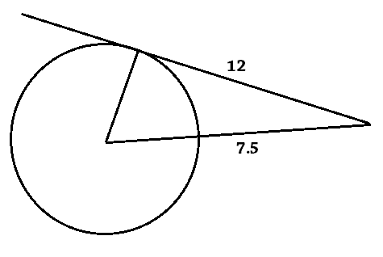5. Assuming the line is tangent to the circle, solve for the radius of the circle.

6. Give two (different) possible values for x in each statement.

A.  B.  C. 

7. What are the vertical and horizontal cross sections (through the middle) of the shapes below?

A. cylinder B. square pyramid C. cone D. sphere

V: V: V: V:

H: H: H: H:

8. Find the length of $\hat{AB}$ given that the area of the sector is 100 .

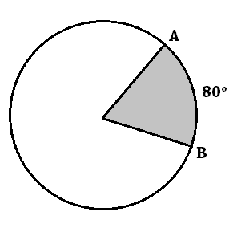

9. How many faces, vertices, and edges does an octagonal prism have?

10. Solve for x and y. 🡪

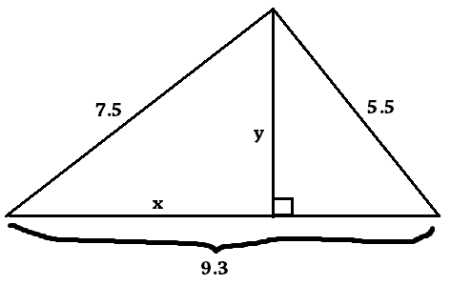

11. Solve for x and y.

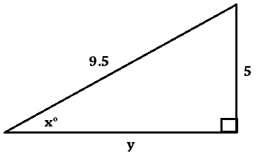

12. What is the radius of a hemisphere with a surface area of ?

13. What is the surface area and volume of a right cylinder and cone with a radius of 4cm and a height of 9cm?

cylinder: cone:

14. Two similar solids have volumes of 1000and 3375. If the surface area of the big solid is 2800 ${cm}^{2}$, what is the surface area of the small solid?

15. What is the surface area of a sphere with a volume of 1767?

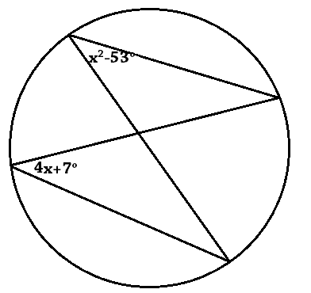16. Solve for x in the circle to the right.

17. Solve for x and y.

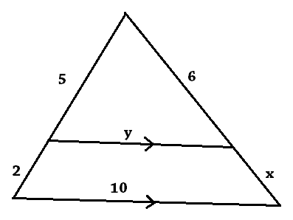

18. What is the surface area of a square pyramid with a base area of 100 and a height of 7cm?

19. What is the surface area of a right rectangular prism with a length of 6cm, a width of 8cm, and a diagonal of 13.8cm?

20. A hiker travels 5 miles due southeast and then 3 miles due east. How far are they from their starting point?

21. Complete the statements about geometry on the surface of a sphere.

A. Straight lines are called ___________________.

B. There are ______ parallel lines, because all lines ____________ at _______ points.

C. The angles of a triangle add up to __________________.

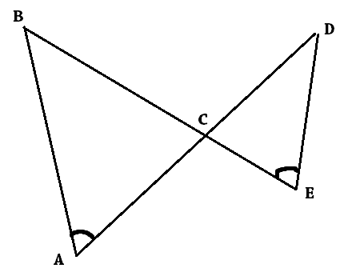22. Write the statement of proportionality and the similarity statement for the triangles below.

23. Solve for x and y in each triangle below (leave answers in radical form.)

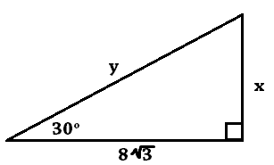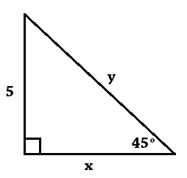A. B.

24. What are three ways two prove two triangles are similar? (Draw an example of each.)

25. How many times bigger is a regular decagon with a side length of 8 in than a regular hexagon with a side length of 8 in? (Be sure to calculate the area of each in your process.)

26. What would the coordinates of (-2, 3) be after the following transformations? Do each transformation separately starting at (-2, 3).

A. A reflection over y = x: B. A 90ᵒ clockwise rotation about the origin:

C. A translation of up 4 and left 5: D. A reflection over the line y = -1:

E. Dilation, scale factor 3, center at (-4, 1): F. An 180ᵒ rotation centered at (1, 1):

27. What is the equation of a circle with a diameter with endpoints at (2, -5) and (4, 1)?

28. What is the probability of randomly picking the following from a deck of 52 cards?

A. A face card (J, Q, K) or a diamond

B. Two of the same card value in row

C. 5 cards that don’t include an ace

29. What is the probability of rolling the following on the sum of two dice?

A. A sum of 9

B. A sum greater than 9

C. A sum that is not 2 or 11

30. How many different ways are there to arrange 7 people:

A. in a line

B. in a circle

31. How many different ways are there to pick 5 people out of a group of 20?

32. What is the probability of picking a point from the shaded region?

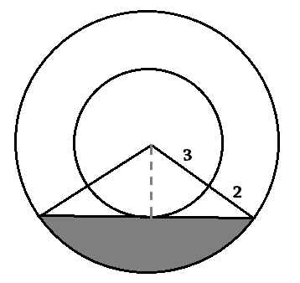

33. While playing a certain game, you have a 40% chance of winning 1 points, a 25% of winning 2 points, a 10% chance of winning 3 points, and a 5% of winning 5 points on each turn.

A. What is the expected value of one turn?

B. How many turns on average would you need to accumulate 15 points?