**Honors Geometry Name________________________________**

**1st Semester Final Exam Review**

1. Find the length, midpoint, and slope of the segment with endpoints of (3a - b, 2b) and (2a + b, -b).

length:

midpoint:

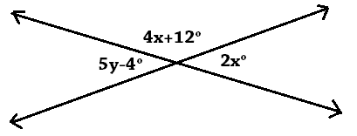slope:

2. Solve for x and y in the picture.

3. Find the circumference of a circle with an area of  .

4. Write the inverse, converse, and contrapositive of .

inverse:

converse:

contrapositive:

5. What # is a contradiction to the statement “the square root of a number is always less than the number”?

6. Write the definition of perpendicular lines as a biconditional statement.

7. Two complementary angles have a ratio of 3:1. What are the measures of the angles?

8. Complete the following truth table.

|  |  |  |  |  |  |  |
| --- | --- | --- | --- | --- | --- | --- |
| p | q | p and q | p or ~q | ~(p and q) | p and ~(p and q) | q→~p |
| t | t |  |  |  |  |  |
| t | f |  |  |  |  |  |
| f | t |  |  |  |  |  |
| f | f |  |  |  |  |  |

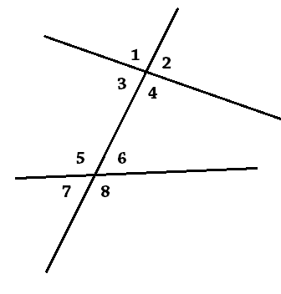9. State what type of angles each pair are.

a. : b. :

c. : d. :

e. : f. :

10. If and , what is the third congruence needed

to prove by…. (Hint: draw a picture.)

a. SAS

b. ASA

c. AAS

11. State what postulate/theorem you would use to prove the triangles are congruent.

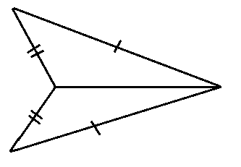a. b. c.

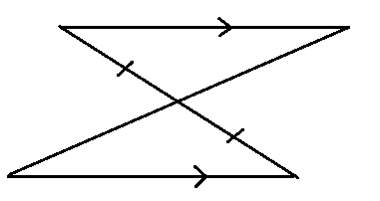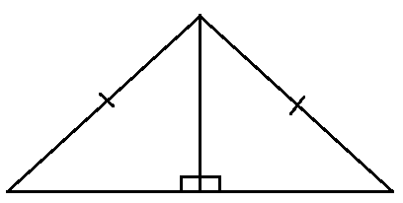

12. Complete the following statements.

a. The perpendicular bisectors intersect at the _______________, which is equidistant from the ____________ of the triangle.

b. The angle bisectors intersect at the ________________, which is equidistant from the ____________ of the triangle.

c. The medians intersect at the _________________ , which is also known as the ______________________ .

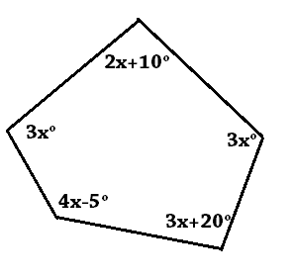

13. Solve for x.

14. Tell whether each statement is true or false.

a. All rectangles are squares.

b. All squares are rhombuses.

c. All kites are parallelograms.

d. All quadrilaterals are rectangles.

e. All rhombuses are parallelograms.

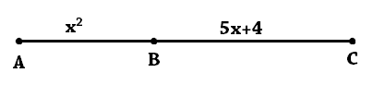

15. If AC = 18, what is AB?

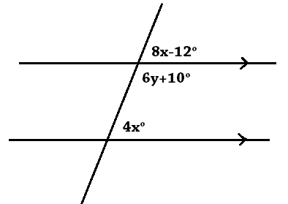

16. Assuming the lines are parallel, solve for x and y.

17. What is the length of the diagonal of a square with a perimeter of 40?

18. What kind of triangle would have side lengths of 5, 6, and 8? (Give two names, one for angles and one for sides.)

19. Write a two-sided inequality for the possible 3rd side of a triangle if the 1st two sides were 5.8 and 10.4 units.

20. Label the property that justifies each statement.

a. If  and , then :

b. : c. AB=5 and CD=5, so AB=CD:

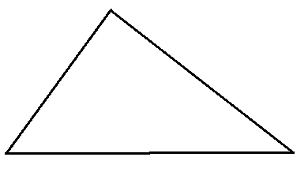21. Sketch and label one of each of the following segments in the following triangle.

a. Perpendicular Bisector b. Median c. Altitude

22. What is the equation of the line perpendicular

to $y=-\frac{1}{2}x+3$ that goes through the point (-3, 1).

23. What is the distance between $y=-\frac{1}{2}x+3$ and $y=-\frac{1}{2}x-2$?

(Hint: It’s not 5.)

24. Describe the difference between inductive and deductive reasoning.

25. Describe the difference between a postulate and a theorem.

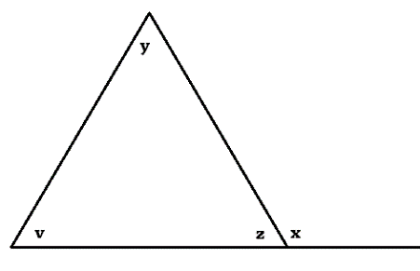

26. State whether each statement must be true.

a. x > z: b. x > v:

c. x = v + z: d. x = v + y:

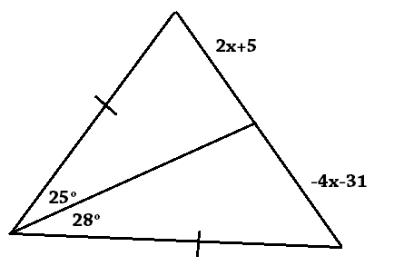

27. Write and solve an inequality for x.

28. What would you assume to do an indirect proof of the following…. “If two lines are perpendicular to the same line, then they are parallel.

29. What is the difference between a concave and convex polygon?

30. Given: , , 

Prove: 

1. , ,  1.

2.  2.

3.  3.

4.  4.

5. ,  5.

6.  6.

7.  7.



8.  8.

9.  9.

10.  10.

11.  11.

31. When are you allowed to draw an auxiliary line in a proof?

32. Describe the difference between the Law of Detachment and Disjunctive Syllogism.

*Be sure to look over quizzes and HW.

*Look online for “Student Created” study guides for some chapters.

*Prepare well for solving, writing multiple types of proofs and making constructions.