Honors Algebra 2 Name _______________________________________
WS 12.5 Hour _______

Determine whether each geometric series converges or diverges. Explain why.
1. | 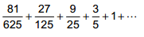 | 2. | 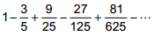
3. | 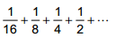 | 4.
Find the sum of each infinite geometric series, if it exists.
5. | 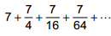 | 6.
7. | 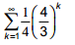 | 8. | 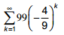
9. |  | 10.
11. | 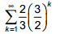 | 12. | 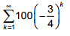
Solve.
13. | Ron won a prize that pays $200,000 the first year and half of the previous year’s amount each year for the rest of his life.
A. | Write the first 4 terms of a series to represent the situation. | B. | Write a general rule for a geometric sequence that models his prize each year.
C. | Estimate Ron’s total prize in the first 10 years. | D. | If Ron lives forever, what is the total of his winnings?
14. | A movie earned $60 million in the first week that it was released. In each successive week, sales declined by about 20%.
A. | Write a general rule for a geometric sequence that models the movie’s sales each week. | B. | Estimate the movie’s total sales in the first 8 weeks.
C. | If this pattern continued indefinitely, what would be the movie’s total sales?

Book work: p. 904 (28, 29, 38, 45, 61 – 64)

